EAST TAMAKI SCHOOL NEWSLETTER



NEWSLETTER NUMBER 14 – 2019 Thursday 6 June
Fa’asilasilaga Numera 14 - 2019 Aso Tofi i le aso ono o Me

Te Kura O Tamaki Rawhiti
Kia Orana, Malo e Lelei, Fakaalofa Lahi Atu, Talofa Lava,
Bula, Kamusta, Tena Koutou Katoa.
Warm greetings to you all.

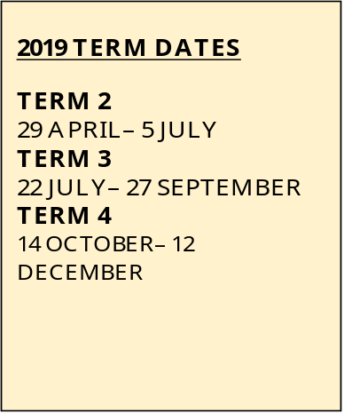
Achievement Review Discussions

Monday 24 June, 1:30pm – 5:30pm
Wednesday 3 July, 1:30pm – 5pm

It is important to meet with your child’s teacher to discuss your child’s learning and also talk about how you can help your child at home.
Please complete and return the form that will be sent home soon with your child. Please note school will close at 1.00pm on Monday 24 June and Wednesday 3 July.

Fa’afetai lava
Sarah Mirams
Principal
Pule a’oga

Samoan Learning Celebration
Friday 7 June, 1:30pm in the hall

Please join us as we celebrate Samoan Language Week
with siva from some classes.
Our new Students Leaders will receive their badges during the celebration. Please join us to congratulate: Hanalina Tanuvasa, Oloveti Vea, Emma Koloamatangi, Joanne Adams, Salome Pomana, Lolo Funganitao, Julius Afaaso, Jay Misa, Anilyza Marsters and Madhyn Tasmania-Ikitule, Shirley-Ann Cullen and MJ Tavita.

Upcoming events:

Mon 10 June – Fri 21 June: Philippines Language and Culture Weeks
Wed 12 June: Philippines Independence Day
Mon 10 June – Fri 12 June: Dental Clinic at school
Friday 21 June: Totara Roopu ‘Bring-a-can’ Mufti Day
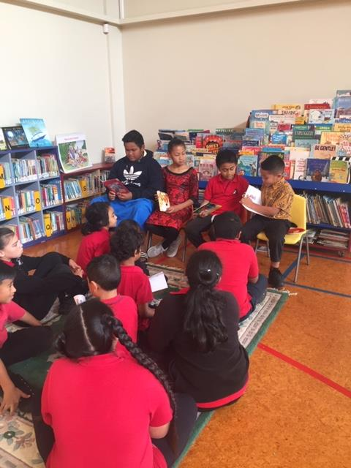
During Samoan Language Week students read stories in Samoan.

