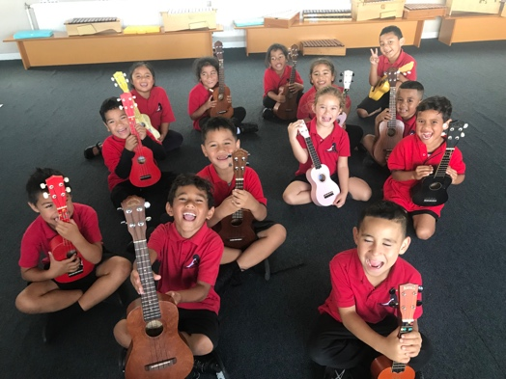

**Weekly Music Lessons**

Each class has a weekly music lesson with our music specialist teacher, Maria Winder in Room 13. Students are developing musicianship and key competencies by actively participating in singing, moving, playing instruments, listening and creating music.

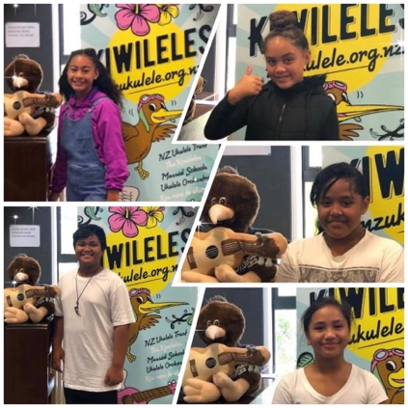

**Important Performance Dates for Year 5/6 Choir, Marimba and Ukulele Groups**

*Parent helpers are needed for the following events. Please email* [*mariaw@easttamaki.school.nz*](mailto:mariaw@easttamaki.school.nz) *or text Maria 027 2268044, if you would like to help.*

* Tuesday 13th August – The Kids Sing Choir Festival at Auckland Town Hall. School choirs from around Auckland compete for Gold, Silver and Bronze awards. The East Tamaki School Choir will be competing in the afternoon session. All competing choirs perform in the evening Gala Concert at Auckland Town Hall. Prizes will be awarded at the end of the Gala Concert. Concert tickets will be available at the end of Term 2.
* Saturday 31st August – NZ Marimba Festival. The East Tamaki Marimba Group will be performng in the 12pm concert at Barfoot & Thompson Stadium, Selwyn College, Kohimarama. Entry by gold coin donation.
* Wednesday 6th November – 7:30pm Concert - APPA Music Festival at Auckland Town Hall. East Tamaki School Choir will perform as part of the massed choirs. The choir will attend 5 rehearsals during Terms 2, 3 & 4, in preparation for the November event. Concert tickets will be available at the end of Term 3.
* Saturday 16th November – 12pm – 3pm - NZ Ukulele Festival at The Trusts Arena Waitakere. This is a FREE family event.

**Sistema Aotearoa**

* Sistema Aotearoa will be teaching all Year Two students at school during Term Two after lunch on Fridays.

**Music Groups for Year 5 and 6 students**

* Senior Ukulele Group – Thursdays at 1:30pm
* Senior Choir – Fridays at 11:30am
* Senior Music Extension Groups- Fridays at 12:10pm. Small groups extend their music skills e.g. Song-writing, composition, instrumental and vocal groups.
* Senior Marimba Group – Fridays at 1:30pm

**Whole School Music Performances**

* Term 2, Friday 31st May – Hook Line & Sing-along, 11:30am - 12:30pm at East Tamaki School. This is a nationwide event to celebrate NZ Music Month. Groups from other Otara schools will be invited to come to East Tamaki School to join our students in singing and playing NZ Music
* Term 3 Fiafia Night – Date to be confirmed
* Term 4 Carols on the Field – Date to be confirmed

**Term One Highlights**

* The Choir performed a waiata for Hon. Jenny Salesa, MP.
* 5 members of the Ukulele Group recorded the vocals for the 2019 Kiwileles CD at Sacred Heart College.
* The Log Drumming group, Marimba Group and Ukulele Group will perform on Thu 4th April during the Art Trail.