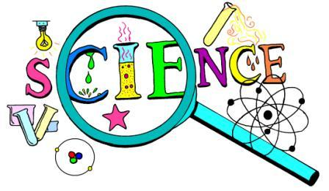

At East Tamaki School teachers work hard to ensure children develop as confident scientific citizens.
Each week every class in the school is taught science by a specialist science teacher called Mrs Armstrong. Last year she worked with scientists at University of Auckland so that she could understand more about science. She returned with many more amazing ideas and knowledge which she is using to help students understand how science has an impact on our world. She also passes ideas onto classroom teachers to use in their classes too.
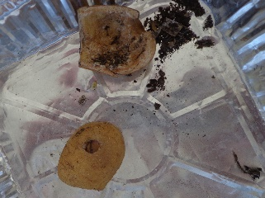
Our students enjoy being involved in science experiments and learning and are always keen to learn why something happens or what happens if…..
I wonder what made the hole in this potato trap?
What evidence is there? Think like a scientist and use your observations skills!!
Please talk to your children about what they have been learning in science as this will help them become more curious and interested in finding out more about their world.
Later this term some Year 6 students will be involved in a Family Science Workshop run by the University of Auckland. This is an after school activity which starts at 5.45pm and finishes at 7.30pm. Parents accompany their children to a fun evening to learn about a science topic. Details will follow towards the end of this month for the students who have been selected to attend.

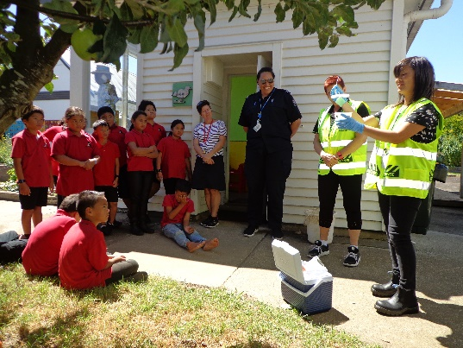
Whilst having the Tongan fruit fly in the Otara area has made moving fruit and vegetables in and out of our school a problem, it has given our students an opportunity to see science in action. Bio-security personnel come to monitor the traps that have been placed in some of our fruit trees on a daily basis and have given students valuable learning opportunities.

